SSIS-MODULE-2

TRANSFORMATIONS

TRANSFERING DATA FROM EXCEL TO FLAT

CHARACTER MAP TRANSFORMATION- PERFORMING THE OPERATION

DATA CONVERSION OPERATION TO TRANSFER THE DATA FROM FLAT TO EXCEL

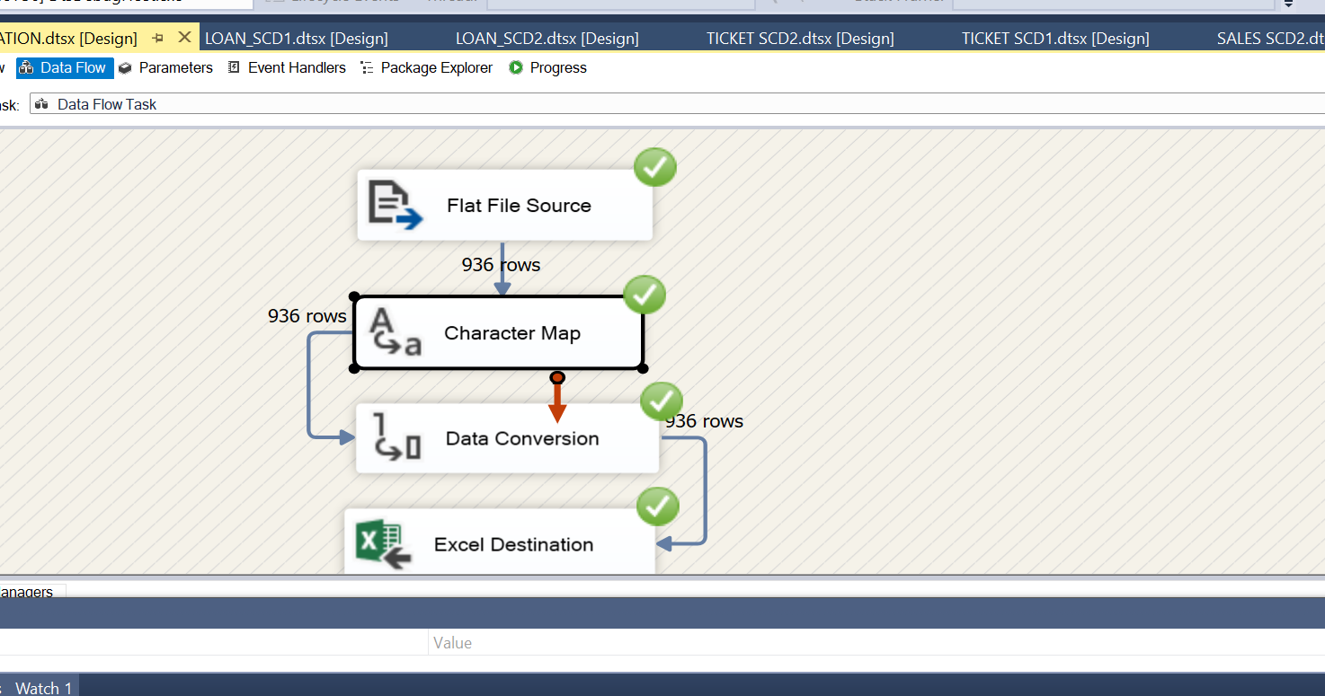

RESULT OF CHARACTER MAPPING

SCD 1 TRANSFORMATION

TRANSFERING THE DATA FROM EXCEL SOURCE TO OLE DB DESTINATION

CREATION OF DESTINATION TABLE TO LOAD THE DATA

SELECTING THE BUSINESS KEY

NEXT WE NEED TO SELECT THE ATTRIBUTES

THEN AFTER SELECTING THE FIXED ATTRIBUTES THE OPERATIONS GET STARTED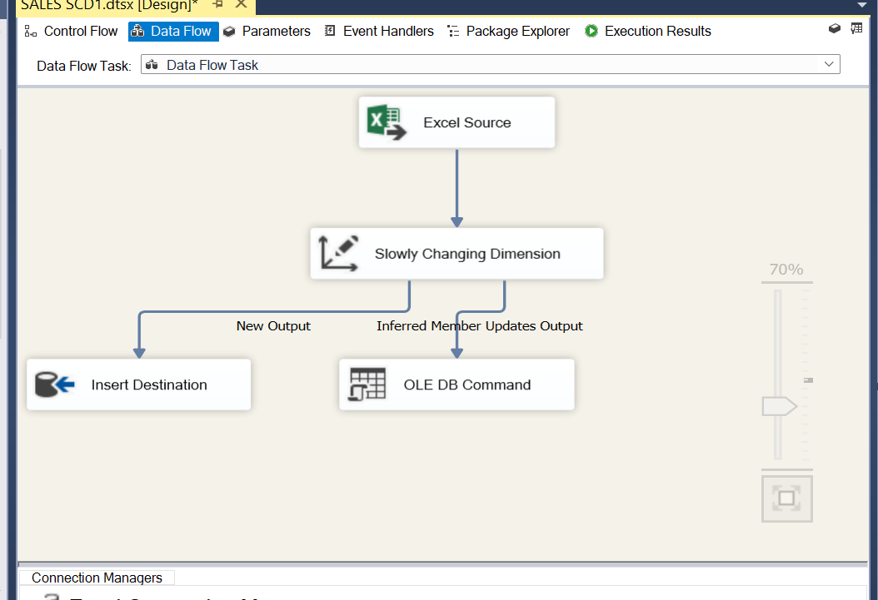

THE EXECUTION IS SUCCESSFULL

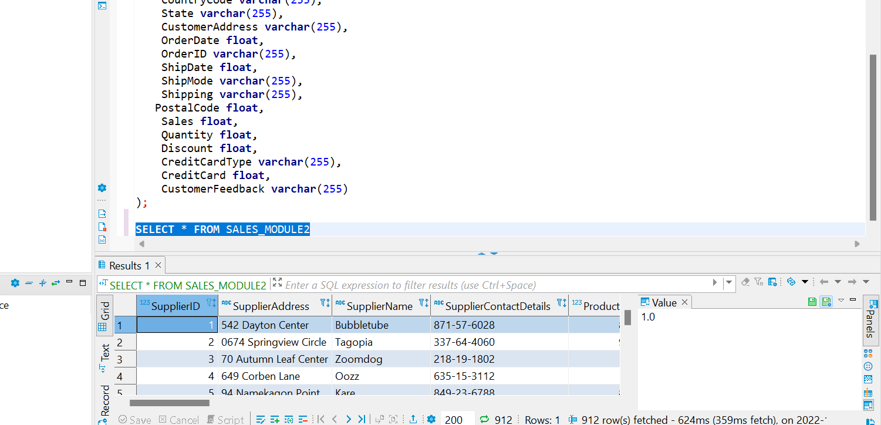

IN THE ABOVE SCREENSHOT WE CAN OBSERVE THAT THE DATA IS TRANSFERRED

UPDATION PROCESS IN SCD1

NOW WE NEED TO CHANGE THE FIXED ATTRIBUTE TO CHANGING ATTRIBUTE FOR UPDATING THE COLUMN

IN THE ABOVE SCREENSHOT WE CAN OBSERVE THAT 1 ROW HAS BEEN UPDATED AFTER CHANGING THE FROM FIXED ATTRIBUTE TO CHANGEBLE ATTRIBUTE

HERE WE CAN SEE THAT SUPPLIER NAME HAS BEEN UPDATED AS ARUNAGIRI FROM BUBBLETUBE.

AND I HAVE USE OTHER FEW DATASOURCES FOR THE SAME OPERATION BELOW PICTURES ARE THE RESULTS OF IT.

CINEMATICKET AS DATASOURCE

S

SCD2 EXECUTION RESULT

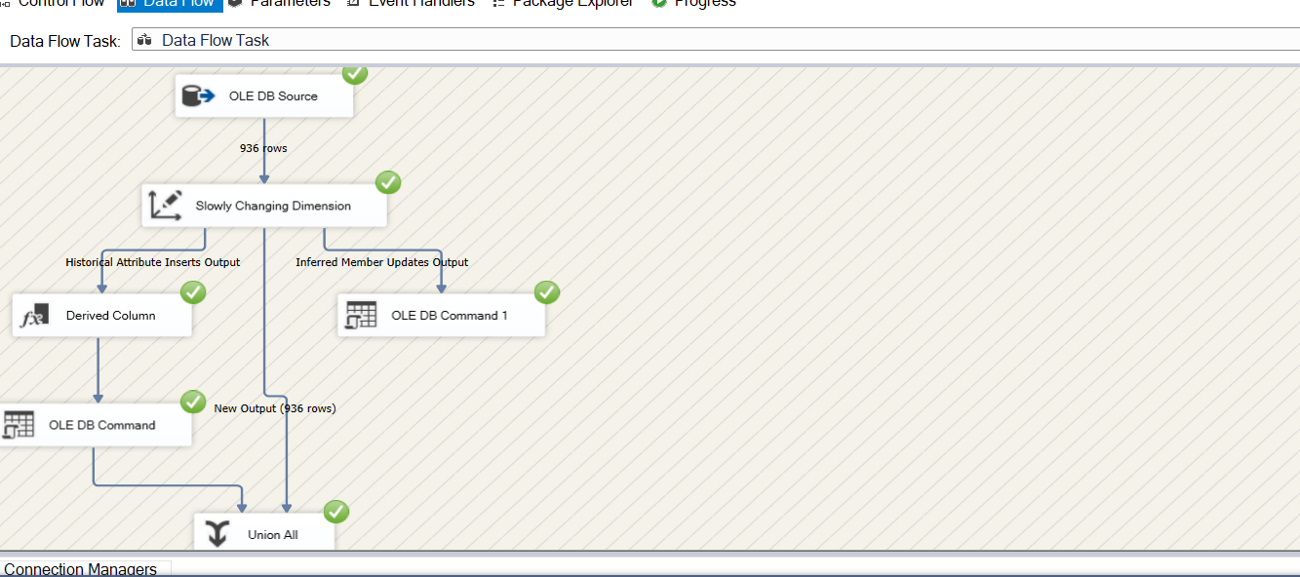

AFTER THE FIRST EXECUTION WE GET THE START DATE IN THE DESTINATION

ONCE AFTER THE UPDATION PROCESS WE GET THE END_DATE RESULT

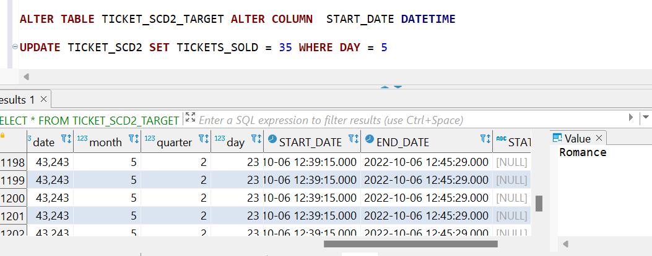

STATUS RRSULT BEFORE UPDATION IS CURRENT

STATUS RESULT AFTER UPDATION IS EXPIRED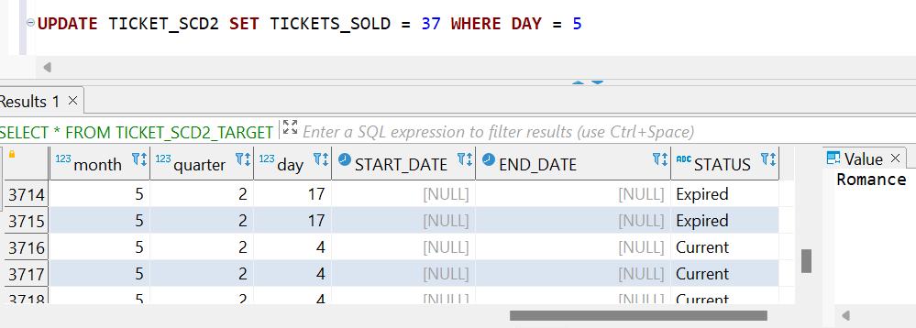

ABOVE IS UPDATION RESULT SUCCESS SCREENSHOT

I HAVE PERFORMED SAME OPERATION ON OTHER DIFFERENT DATA SOURCES AND THE BELOW PICTURES ARE THE RESULT OF IT.

RESULT OF LOAN SCD2

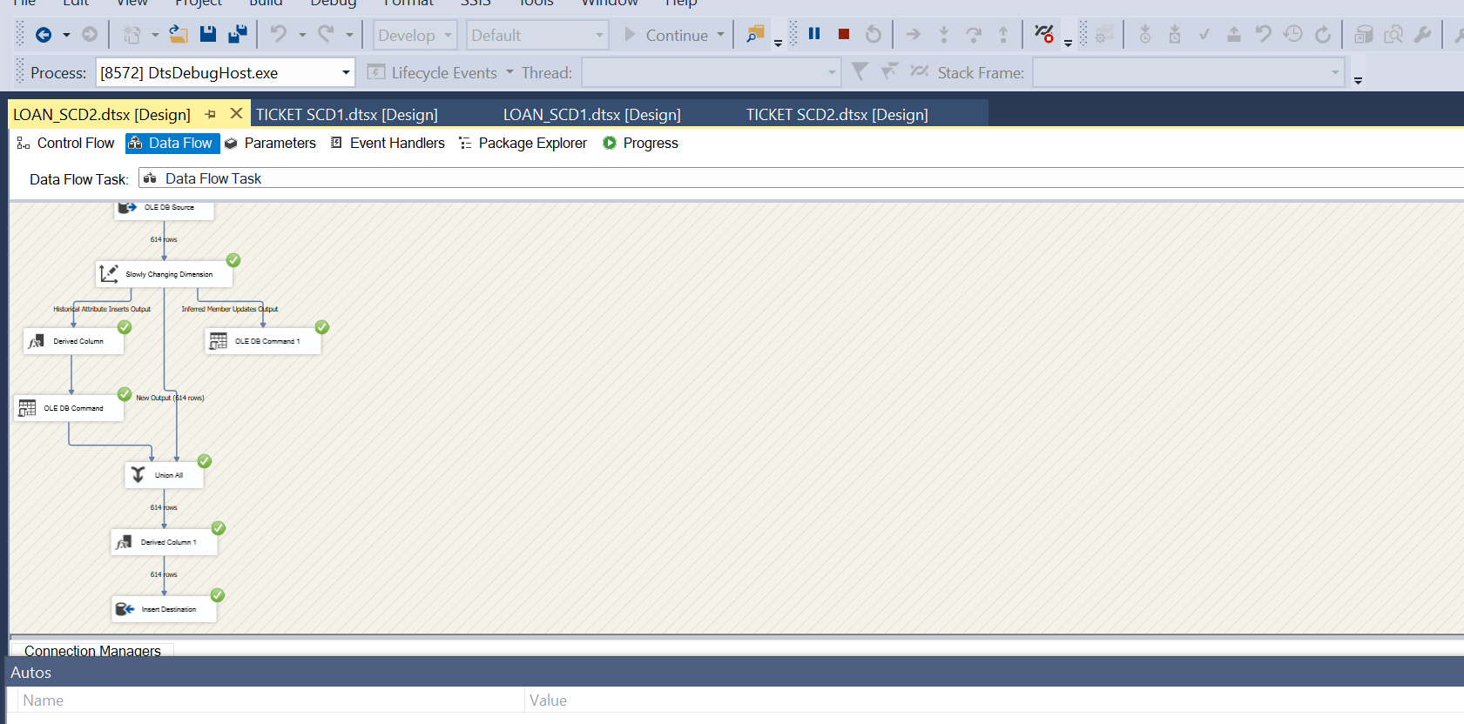

RESULT OF SALES SCD2

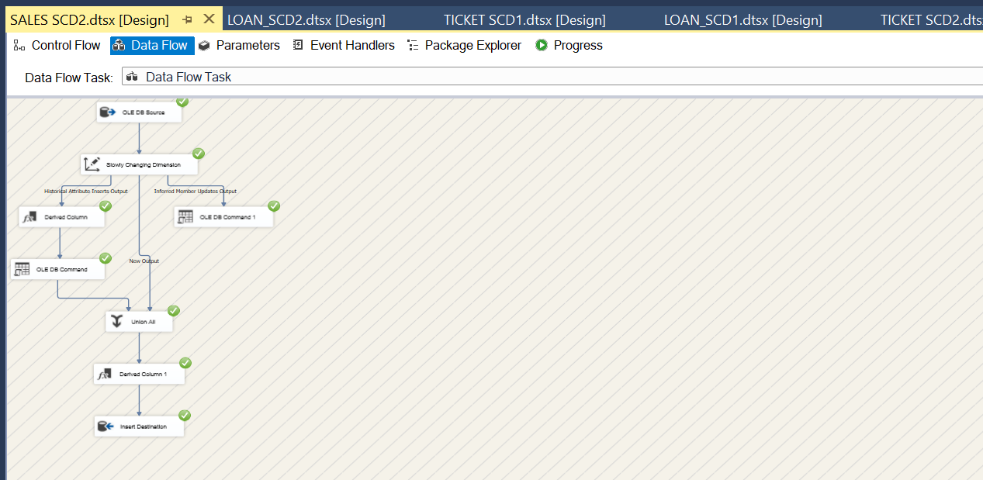

AGGREGRATION TASK

AGGREGATION OPERATION WINDOW

RESULTS OF AGGREGATION TASK

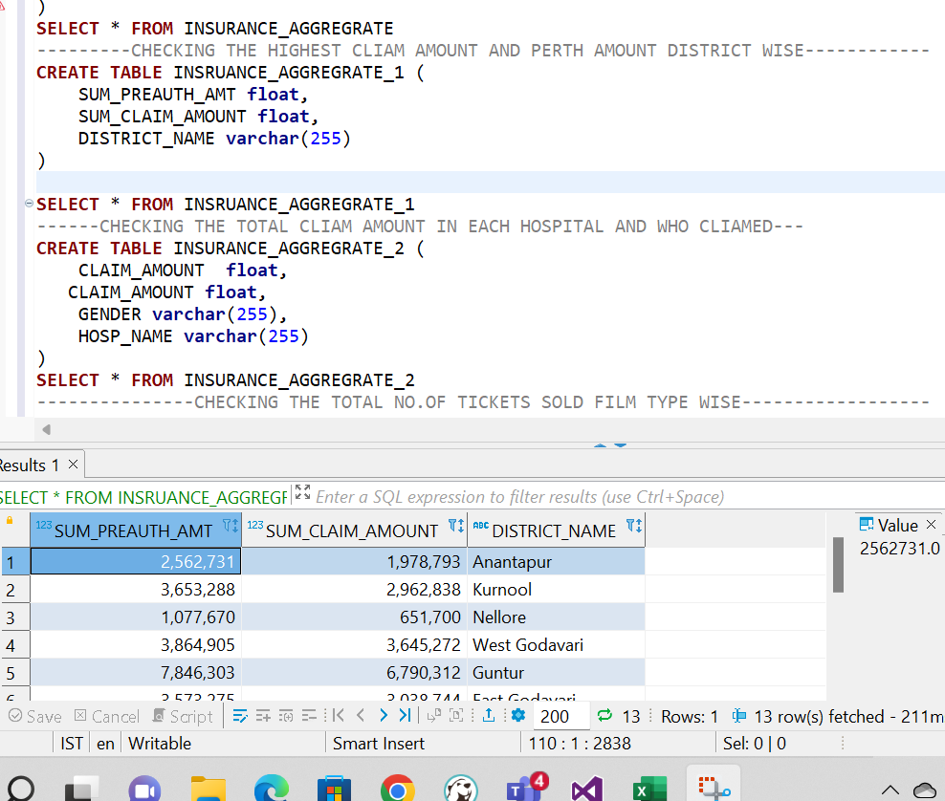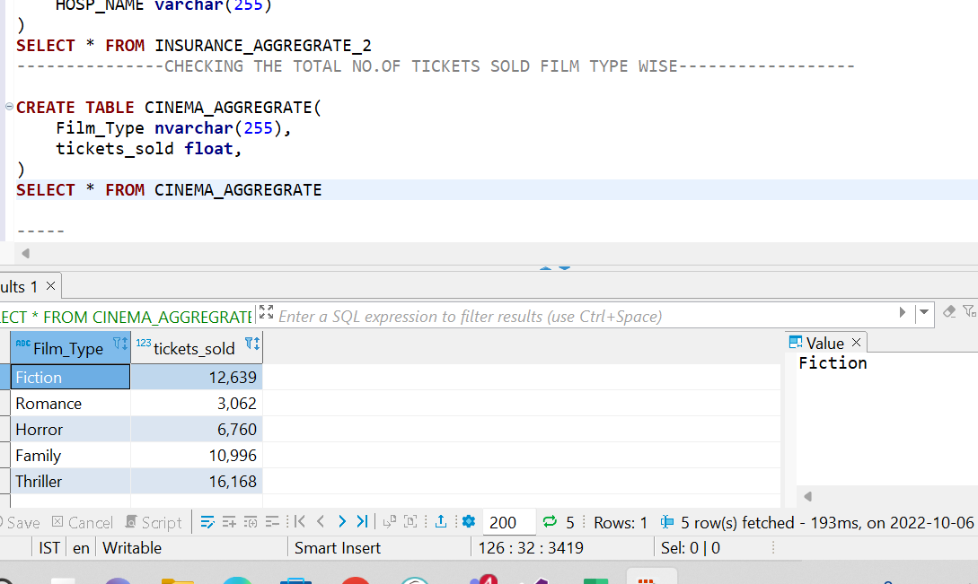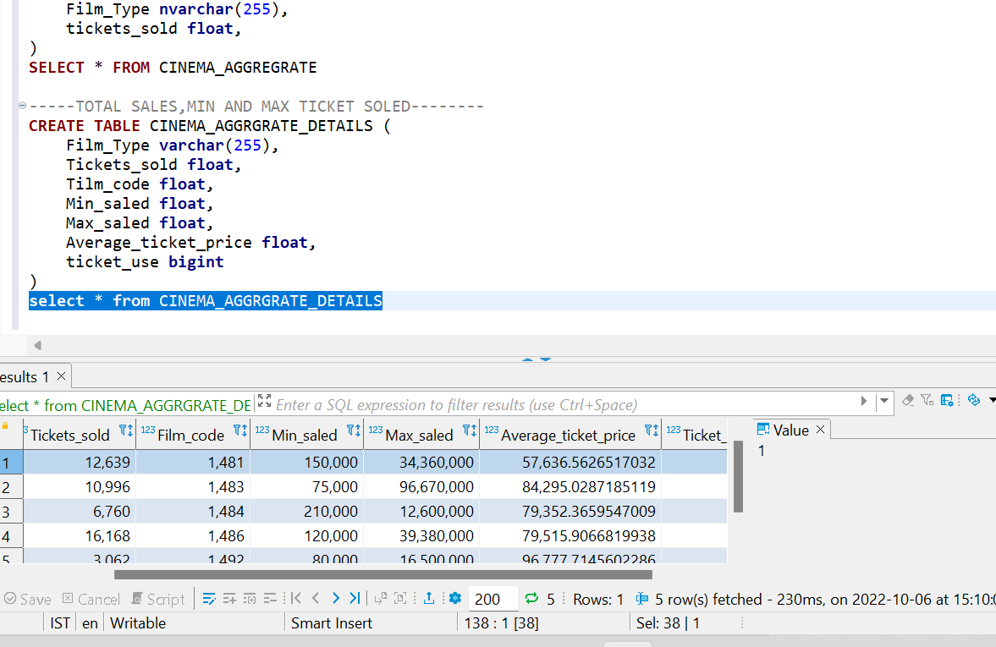

TABLES CREATED TO GET THE RESULT FROM AGGREGRATION TRANSFORMATION

------AGGREGRATE-------------------INSURANCE SOURCE--

**SELECT** * **FROM** FA_INSURANCE_M2

---SUM---COUNT---GROUPBY

----CHECKING THE TOTAL CLAIM AMOUNT GROUP BY GENDER--------

**CREATE** **TABLE** INSURANCE_AGGREGRATE (

SUM_CLAIM_AMOUNT **float**,

COUNT_AGE **DECIMAL**(20,0),

GENDER **varchar**(255)

)

**SELECT** * **FROM** INSURANCE_AGGREGRATE

---------CHECKING THE HIGHEST CLIAM AMOUNT AND PERTH AMOUNT DISTRICT WISE------------

**CREATE** **TABLE** INSRUANCE_AGGREGRATE_1 (

SUM_PREAUTH_AMT **float**,

SUM_CLAIM_AMOUNT **float**,

DISTRICT_NAME **varchar**(255)

)

**SELECT** * **FROM** INSRUANCE_AGGREGRATE_1

------CHECKING THE TOTAL CLIAM AMOUNT IN EACH HOSPITAL AND WHO CLIAMED---

**CREATE** **TABLE** INSURANCE_AGGREGRATE_2 (

CLAIM_AMOUNT **float**,

CLAIM_AMOUNT **float**,

GENDER **varchar**(255),

HOSP_NAME **varchar**(255)

)

**SELECT** * **FROM** INSURANCE_AGGREGRATE_2

---------------CHECKING THE TOTAL NO.OF TICKETS SOLD FILM TYPE WISE------------------ SOURCE CINEMA TICKET

**CREATE** **TABLE** CINEMA_AGGREGRATE(

Film_Type **nvarchar**(255),

tickets_sold **float**,

)

**SELECT** * **FROM** CINEMA_AGGREGRATE

-----TOTAL SALES,MIN AND MAX TICKET SOLED--------

**CREATE** **TABLE** CINEMA_AGGRGRATE_DETAILS (

Film_Type **varchar**(255),

Tickets_sold **float**,

Film_code **float**,

Min_saled **float**,

Max_saled **float**,

Average_ticket_price **float**,

ticket_use **bigint**

)

**select** * **from** CINEMA_AGGRGRATE_DETAILS